|  |  |  |
| --- | --- | --- |
| **Chapter** | **Title** | **Page No.** |
| 1. | Introduction | 1-2 |
| 2. | Literature Review | 3-4 |
| 3. | Problem Identification | 5-6 |
| 4. | Methodology  4.1 Cloud Infrastructure Design  4.2 System Deployment  4.3 SIEM Deployment  4.4 Attack & Hardening | 7-20 |
| 5. | Results | 21-23 |
| 6. | Conclusion | 24-25 |
| 7. | References | 26 |
| 8. | Bibliography | 27 |
|  |  |  |

**A Minor Project (Phase I) Report On**

**Attack, Detect and Secure the Environment**

**Submitted to**

**CHHATTISGARH SWAMI VIVEKANAND TECHNICAL UNIVERSITY,**

**BHILAI**



***in partial fulfillment of requirement for the award of degree* of**

**Bachelor of Technology**

**In**

**Computer Science & Engineering (AI & ML)**

**SEMESTER 5th**

**By**

**Rahul Chandrakar, 301310923114, CD2135**

**Ayush Kumar Singh, 301310923050, CD2162**

**Anuj Priyadarshi, 301310923040, CD2119**

**Harsh Kumar, 301310923070, CD2205**

**Under the Guidance of**

**Dr. Rupesh Mishra**

**Co-Head of Department and**

**Associate Professor AI / AIML**



**DEPARTMENT OF COMPUTER SCIENCE AND**

**ENGINEERING (AI&ML)**

**RUNGTA COLLEGE OF ENGINEERING AND TECHNOLOGY**

**KOHKA-KURUD ROAD, BHILAI, CHHATTISGARH, INDIA**

**Session: 2025-26**

**D E C L A R A T I O N**

We, the undersigned, solemnly declare that this report on the project work entitled “Attack, Detect and Secure the Environment ”, is based on our own work carried out during the course of our study under the guidance of Dr. Rupesh Mishra.

We assert that the statements made and conclusions drawn are an outcome of the project work. We further declare that to the best of our knowledge and belief the report does not contain any part of any work which has been submitted for the award of any other degree certificate in this University or any other University.

Signatures

Rahul Chandrakar

301310923114

CD2135

Ayush Kumar Singh

301310923050

CD2162

Anuj Priyadarshi

301310923040

CD2119

Harsh Kumar

301310923070

CD2205

**C E R T I F I C A T E**

This is to certify that this report on the project submitted is an outcome of the project work entitled “ Attack, Detect and Secure the Environment ”**,** carried out by the students in the **DECLARATION**, is carried out under my guidance and supervision for the award of Degree in Bachelor of Technology in Computer Science Engineering (AI & ML) of Chhattisgarh Swami Vivekanand Technical University, Bhilai(C.G.), India.

To the best of my knowledge, the report...

1. Embodies the work of the student(s) themselves,
2. Has duly been completed,
3. Fulfills the requirement of the Ordinance relating to the B.Tech. degree of the University, and
4. Is up to the desired standard for the purpose for which it is submitted.

Signature

**Dr. Rupesh Mishra**

**Co-Head of Department**

This project work as mentioned above is hereby being recommended and forwarded for examination and evaluation by the University,

**Dr. Padmavati Shrivastava**

Head of Department of CSE (AI/AIML),

Rungta College of Engineering & Technology,

Kohka - Kurud Road, Bhilai(C.G.), India

**C E R T I F I C A T E B Y T H E E X A M I N E R S**

This is to certify that this project work entitled “ Attack, Detect and Secure the Environment”**,** submitted by…

Rahul Chandrakar, 301310923114, CD2135

Ayush Kumar Singh, 301310923050, CD2162

Anuj Priyadarshi, 301310923040, CD2119

Harsh Kumar, 301310923070, CD2205

is duly examined by the undersigned as a part of the examination for the award of Bachelor of Technology degree in Computer Science & Engineering (AI & ML) of Chhattisgarh Swami Vivekanand Technical University, Bhilai.

Internal Examiner External Examiner

Name & Signature Name & Signature

Date: Date:

**A C K N O W L E D G E M E N T S**

It is a matter of profound privilege and pleasure to extend our sense of respect and deepest gratitude to our project guide Dr. Rupesh Mishra**,** Department of Computer Science & Engineering (AI & ML) under whose precise guidance and gracious encouragement we had the privilege to work.

We avail this opportunity to thank respected Dr. Padmavati Shrivastava,Head of the Department of Computer Science & Engineering (AI & ML) for facilitating such a pleasant environment in the department and also for providing everlasting encouragement and support throughout.

We acknowledge with the deep sense of responsibility and gratitude the help rendered byrespected Dr. Manish Manoria, Director General, Rungta Educational Foundation, Bhilai, Dr. Y. M. Gupta, Director(Academics), and Dr. Chinmay Chandrakar, Dean(Academics), of Rungta College of Engineering and Technology, Bhilai for infusing endless enthusiasm & instilling a spirit of dynamism.

We would also like to thank all faculty members of our department, and the supporting staff for always being helpful over the years.

Last but not the least, We would like to express our deepest gratitude to our parents and the management of Rungta College of Engineering and Technology, Bhilai, respected Shri Santosh Ji Rungta, Chairman, respected Dr. Sourabh Rungta, Vice Chairman, and respected Shri Sonal Rungta,Secretary, of Rungta Educational Foundation, Bhilai for their continuous moral support and encouragement.

We hope that we will make everybody proud of our achievements..

Rahul Chandrakar, 301310923114, CD2135

Ayush Kumar Singh, 301310923050, CD2162

Anuj Priyadarshi, 301310923040, CD2119

Harsh Kumar, 301310923070, CD2205

**CHAPTER 1: INTRODUCTION**

In recent years, cloud computing has become an essential part of modern information technology infrastructure. Organizations across the world are rapidly migrating their business applications, data storage, and enterprise services to cloud platforms such as Microsoft Azure due to their scalability, flexibility, and cost effectiveness. However, along with these advantages, cloud environments also introduce significant security challenges. Improper configuration, weak authentication mechanisms, and lack of monitoring often expose cloud systems to cyber-attacks.

Cybersecurity incidents such as unauthorized access, brute-force attacks, web application exploitation, and privilege escalation have increased drastically in cloud environments. Attackers actively scan public cloud resources to identify vulnerable systems and exploit them within minutes of deployment. Therefore, securing cloud infrastructure is not only dependent on deploying resources but also on continuously monitoring, detecting, and responding to security threats in real time.

This project, titled **“Attack, Detect & Secure the Environment”**, aims to simulate a real-world enterprise cloud environment on Microsoft Azure and demonstrate the complete cybersecurity lifecycle. The project is divided into two major phases. In the first phase, a small-scale enterprise infrastructure is deployed in an intentionally unsecured state to understand how attackers exploit system weaknesses. Various attack techniques such as network scanning, SSH brute-force attempts, and web enumeration are performed to generate realistic security events.

In the second phase, the project focuses on detection, analysis, and defense. A Security Information and Event Management (SIEM) system is deployed to collect and analyze logs from different servers. Security alerts generated by the SIEM are studied to identify attack patterns, indicators of compromise, and system misconfigurations. Based on these findings, industry-standard security hardening techniques are applied, including SSH hardening, firewall configuration, network segmentation, and service-level security improvements.

We performing this project take on the roles of both **Red Team (attackers)** and **Blue Team (defenders)**, providing hands-on exposure to offensive and defensive cybersecurity practices. After implementing the security controls, the environment is re-attacked to validate the effectiveness of the applied hardening measures by comparing logs and alerts before and after securing the systems.

The primary objective of this project is to provide practical knowledge of cloud security, attack detection, and incident response while closely aligning with real-world Security Operations Center (SOC) practices. This project helps in understanding how cloud infrastructure can be securely designed, monitored, and protected against modern cyber threats.

**CHAPTER 2: LITERATURE REVIEW**

With the increasing adoption of cloud computing, securing cloud-based infrastructures has become a critical concern for organizations. Several studies have highlighted the importance of proactive security measures, real-time monitoring, and incident response mechanisms to prevent and mitigate cyber threats in cloud environments.

2.1 Cloud Security Challenges

Cloud environments provide flexible and scalable resources, but they also introduce unique security challenges. Misconfigured virtual networks, improperly secured virtual machines, weak authentication mechanisms, and lack of centralized logging can leave systems vulnerable to attacks. According to Smith et al. (2022), a significant number of cloud security breaches occur due to human errors and misconfigurations rather than inherent flaws in cloud platforms.

2.2 Virtualization and Network Security

Virtualization technologies, including virtual machines and virtual networks, are widely used in cloud platforms. Studies by Kumar & Gupta (2021) emphasize the importance of proper subnet segmentation, firewall configurations, and access controls to prevent unauthorized lateral movement within cloud networks. Implementing internal and DMZ subnets helps in isolating sensitive resources and reducing attack surfaces.

2.3 Identity and Access Management (IAM)

Identity and Access Management (IAM) is a foundational aspect of cloud security. Tools like FreeIPA provide LDAP and Kerberos-based authentication, enabling centralized identity management. Research by Chen et al. (2020) demonstrates that weak identity management and poor password policies are often exploited by attackers to gain administrative access to cloud resources.

2.4 Web Server and Application Security

Web applications are frequently targeted in cyber-attacks, including SQL injection, directory traversal, and unauthorized access attempts. Studies by Patel & Singh (2021) highlight the significance of properly configuring web servers such as Apache or Nginx, securing directories, and monitoring web logs to detect malicious activity.

2.5 Security Information and Event Management (SIEM)

SIEM systems play a critical role in modern security operations by collecting and analyzing logs from multiple sources to detect security incidents. Wazuh, Splunk, and ELK are widely used open-source SIEM solutions that provide centralized log management, real-time alerts, and detailed event analysis. According to Jones et al. (2022), SIEM integration is essential for detecting advanced persistent threats and monitoring attack patterns in cloud environments.

2.6 Red Team and Blue Team Approaches

The Red Team simulates real-world attacks to identify vulnerabilities, while the Blue Team focuses on defense, log analysis, and hardening the infrastructure. Literature emphasizes the effectiveness of combining offensive and defensive approaches to provide hands-on learning and strengthen overall security posture (Brown & Taylor, 2021).

2.7 Gaps in Existing Studies

While many studies discuss cloud security and attack detection, there is limited hands-on research combining both **attack simulation and defensive hardening** in a controlled cloud environment. This project addresses this gap by providing a practical, end-to-end implementation of attacking, detecting, and securing cloud infrastructure using Azure.

2.8 Summary

The literature highlights the importance of cloud security practices, centralized logging, identity management, network segmentation, and SIEM monitoring. This review establishes the theoretical foundation for deploying a small-scale enterprise environment on Azure, intentionally exposing vulnerabilities, generating attack logs, and applying hardening techniques, which form the basis of the current project.

**CHAPTER 3: PROBLEM IDENTIFICATION**

Despite the many advantages offered by cloud computing, deploying infrastructure without proper security measures can introduce significant risks. In real-world scenarios, organizations often face challenges in maintaining a secure cloud environment, leading to potential data breaches, unauthorized access, and service disruptions.

3.1 Risks of Unsecured Cloud Infrastructure

Unsecured cloud infrastructure is highly vulnerable to cyber-attacks. Open ports, weak authentication, and default configurations allow attackers to gain unauthorized access quickly. According to recent studies, misconfigured virtual machines and networks are among the leading causes of cloud security incidents. Such vulnerabilities can lead to data theft, service downtime, and loss of organizational reputation.

3.2 Common Misconfigurations

Many cloud deployments suffer from configuration issues that increase exposure to threats. Examples include:

* Lack of firewall or network security group restrictions
* Weak or default passwords on critical systems
* Open SSH access without key-based authentication
* Web servers left with default directories or configurations

These misconfigurations create easy entry points for attackers and make real-time monitoring difficult.

3.3 Need for Centralized Logging

Without centralized logging, detecting attacks and understanding system behavior is challenging. Traditional logging mechanisms on individual servers are often insufficient to provide complete visibility into security incidents. Centralized log collection using SIEM solutions allows for real-time monitoring, alert generation, and efficient investigation of suspicious activities.

3.4 Gaps in Traditional Security Approaches

Conventional security methods often focus on static measures such as firewalls and antivirus software. However, these approaches fail to address dynamic threats, advanced attacks, and insider threats. Red Team simulations combined with SIEM analysis provide hands-on learning to identify vulnerabilities, understand attack patterns, and apply security hardening effectively.

3.5 Summary

The primary problem addressed by this project is the risk posed by unsecured cloud infrastructure and the lack of integrated monitoring. By intentionally deploying a vulnerable environment and simulating real attacks, this project highlights the necessity of centralized logging, detection, and systematic hardening to build a secure and resilient cloud infrastructure.

**CHAPTER 4: METHODOLOGY**

This chapter describes the step-by-step methodology followed to deploy, attack, detect, and secure a cloud infrastructure on Microsoft Azure. The approach combines cloud infrastructure design, system deployment, SIEM implementation, attack simulation, and security hardening.

4.1 Cloud Infrastructure Design

4.1.1 Azure Account Usage

The project was implemented using a **Microsoft Azure Student Account**. Azure provides virtualized cloud resources such as virtual machines, virtual networks, storage accounts, and security groups, enabling a scalable and flexible enterprise environment for hands-on learning.

4.1.2 Resource Group Naming

All resources were created inside a single **Azure Resource Group**.

* Resource Group Name: Firewallis-Tech
* Purpose: Ensure all project resources are organized, easy to manage, and clearly associated with the group.
* Importance: Resources outside this group were intentionally excluded from evaluation.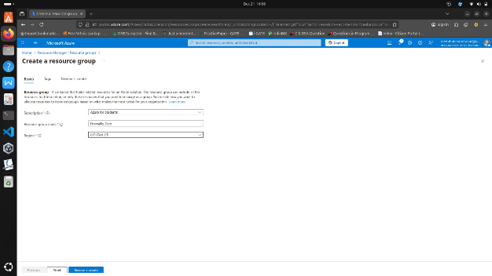

4.1.3 VNet and Subnet Design

A single **Virtual Network (VNet)** was created with two subnets:

* **Internal Subnet** – Hosting VM1 (Internal Server) and VM3 (SIEM Server)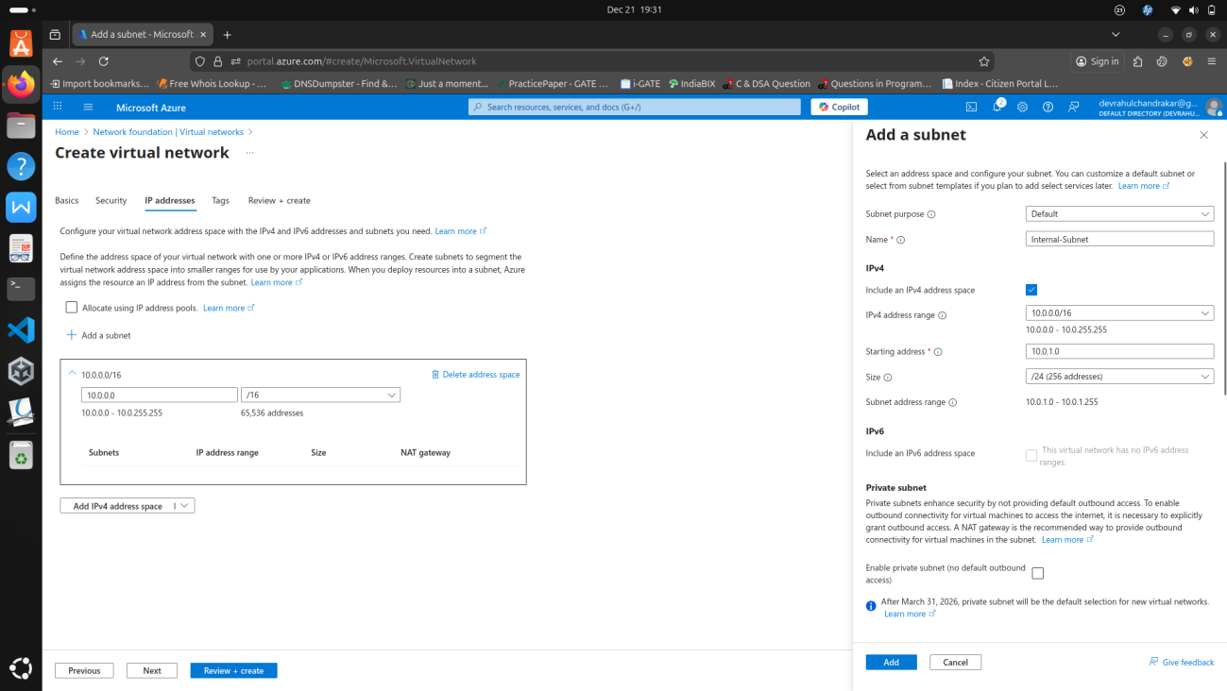
* **DMZ Subnet** – Hosting VM2 (Web Server)  
   This design simulates a real-world enterprise network by separating internal services from external-facing web services, allowing controlled testing of attacks and defenses

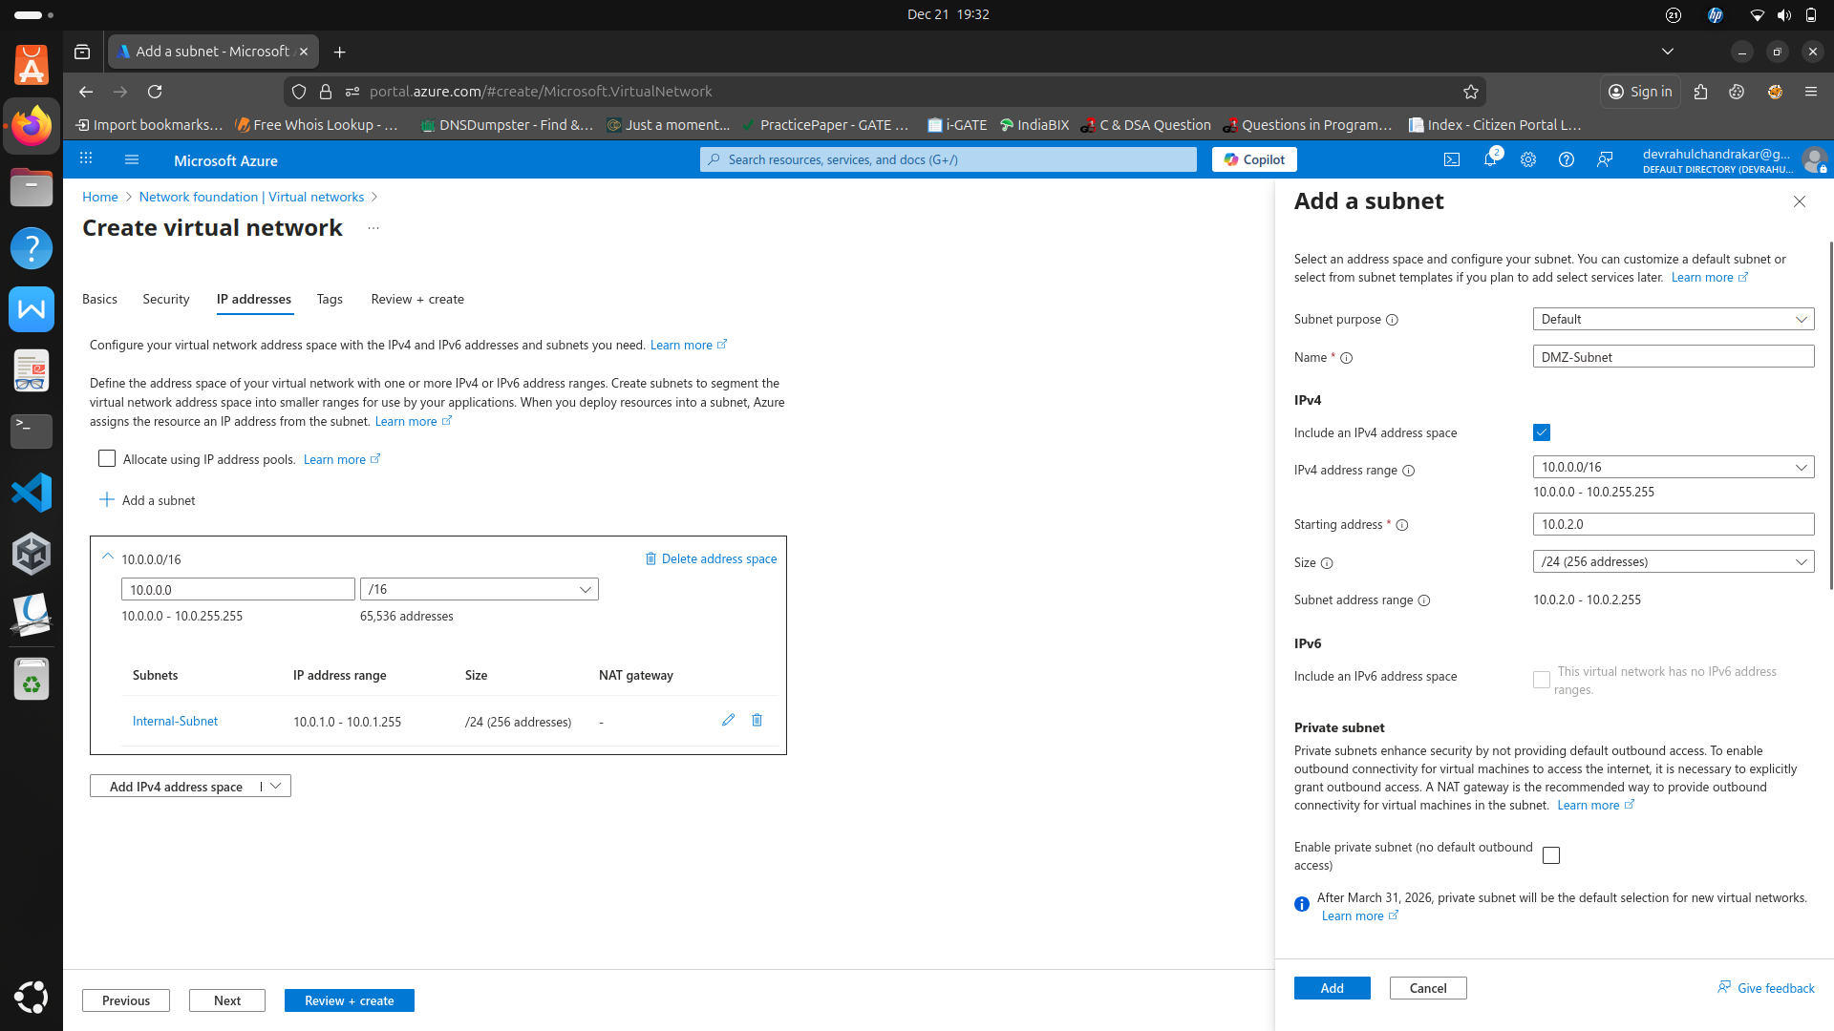

4.2 System Deployment

4.2.1 VM1: FreeIPA & File Server Setup

* Role: Internal Server

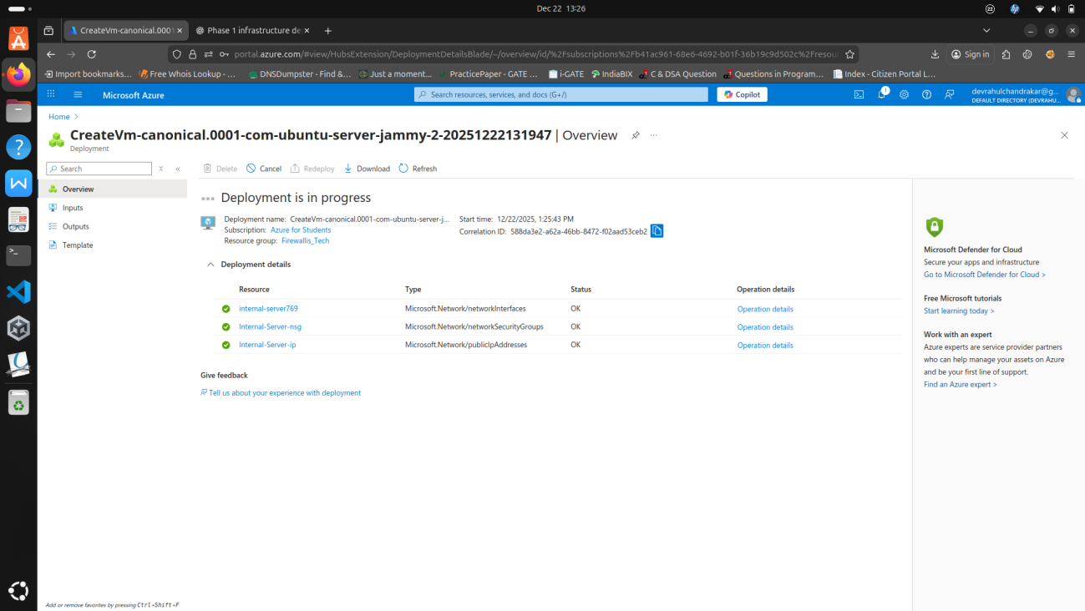

* Services Installed: FreeIPA (LDAP/Kerberos) for identity management, Samba/NFS for file storage

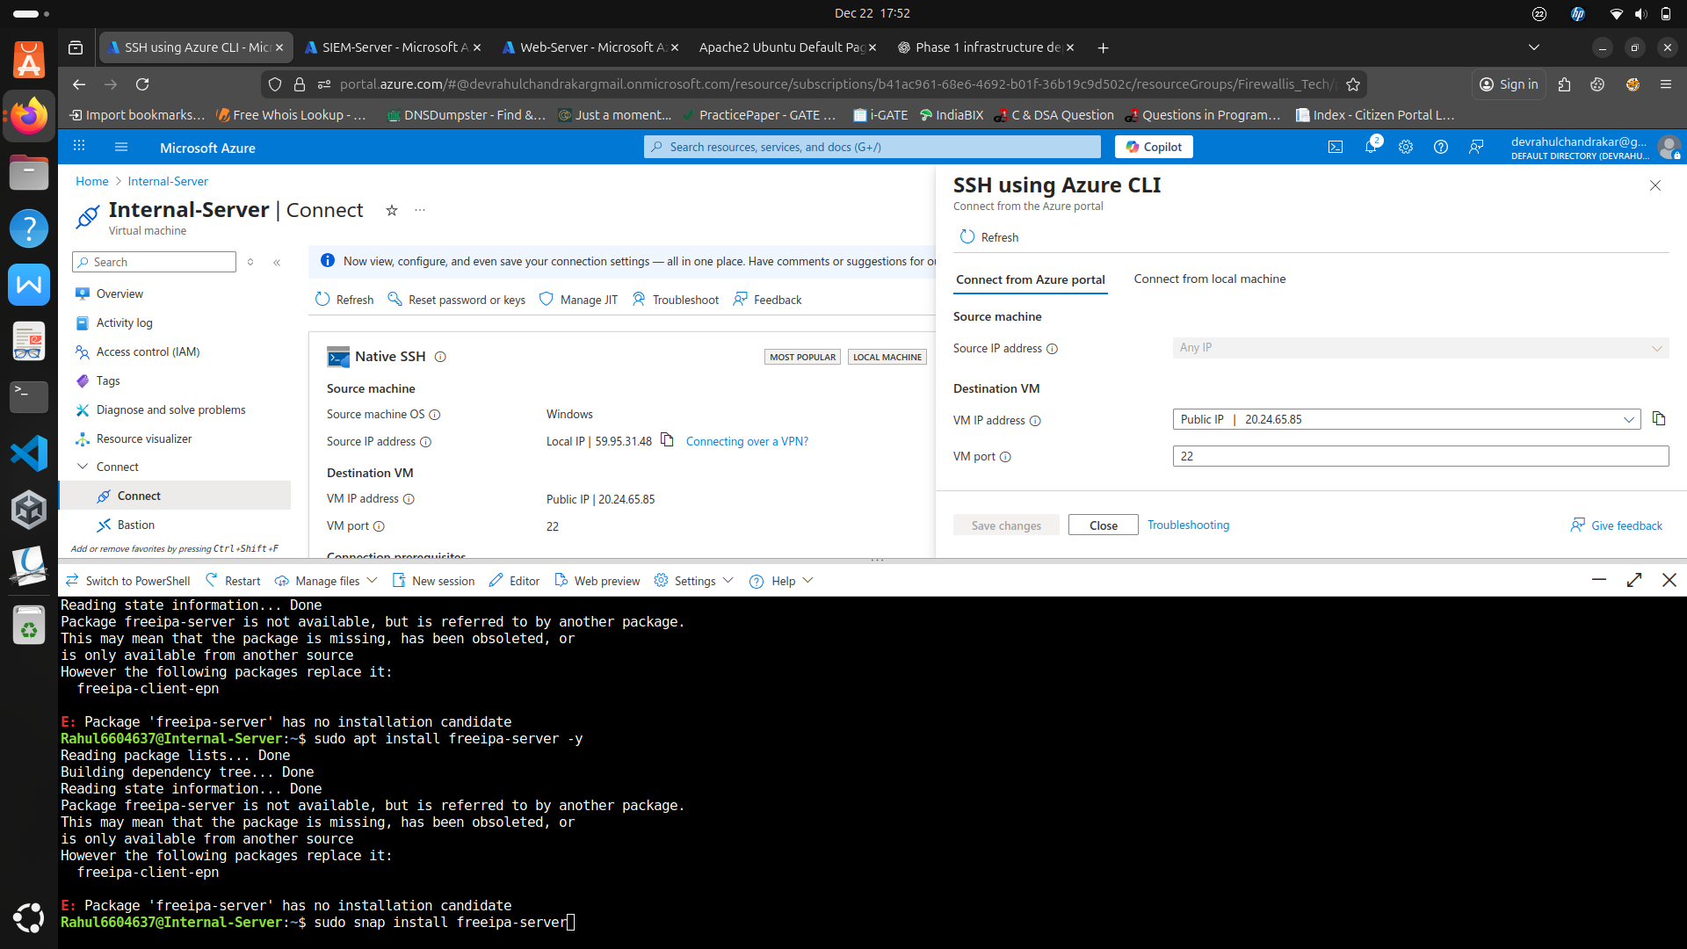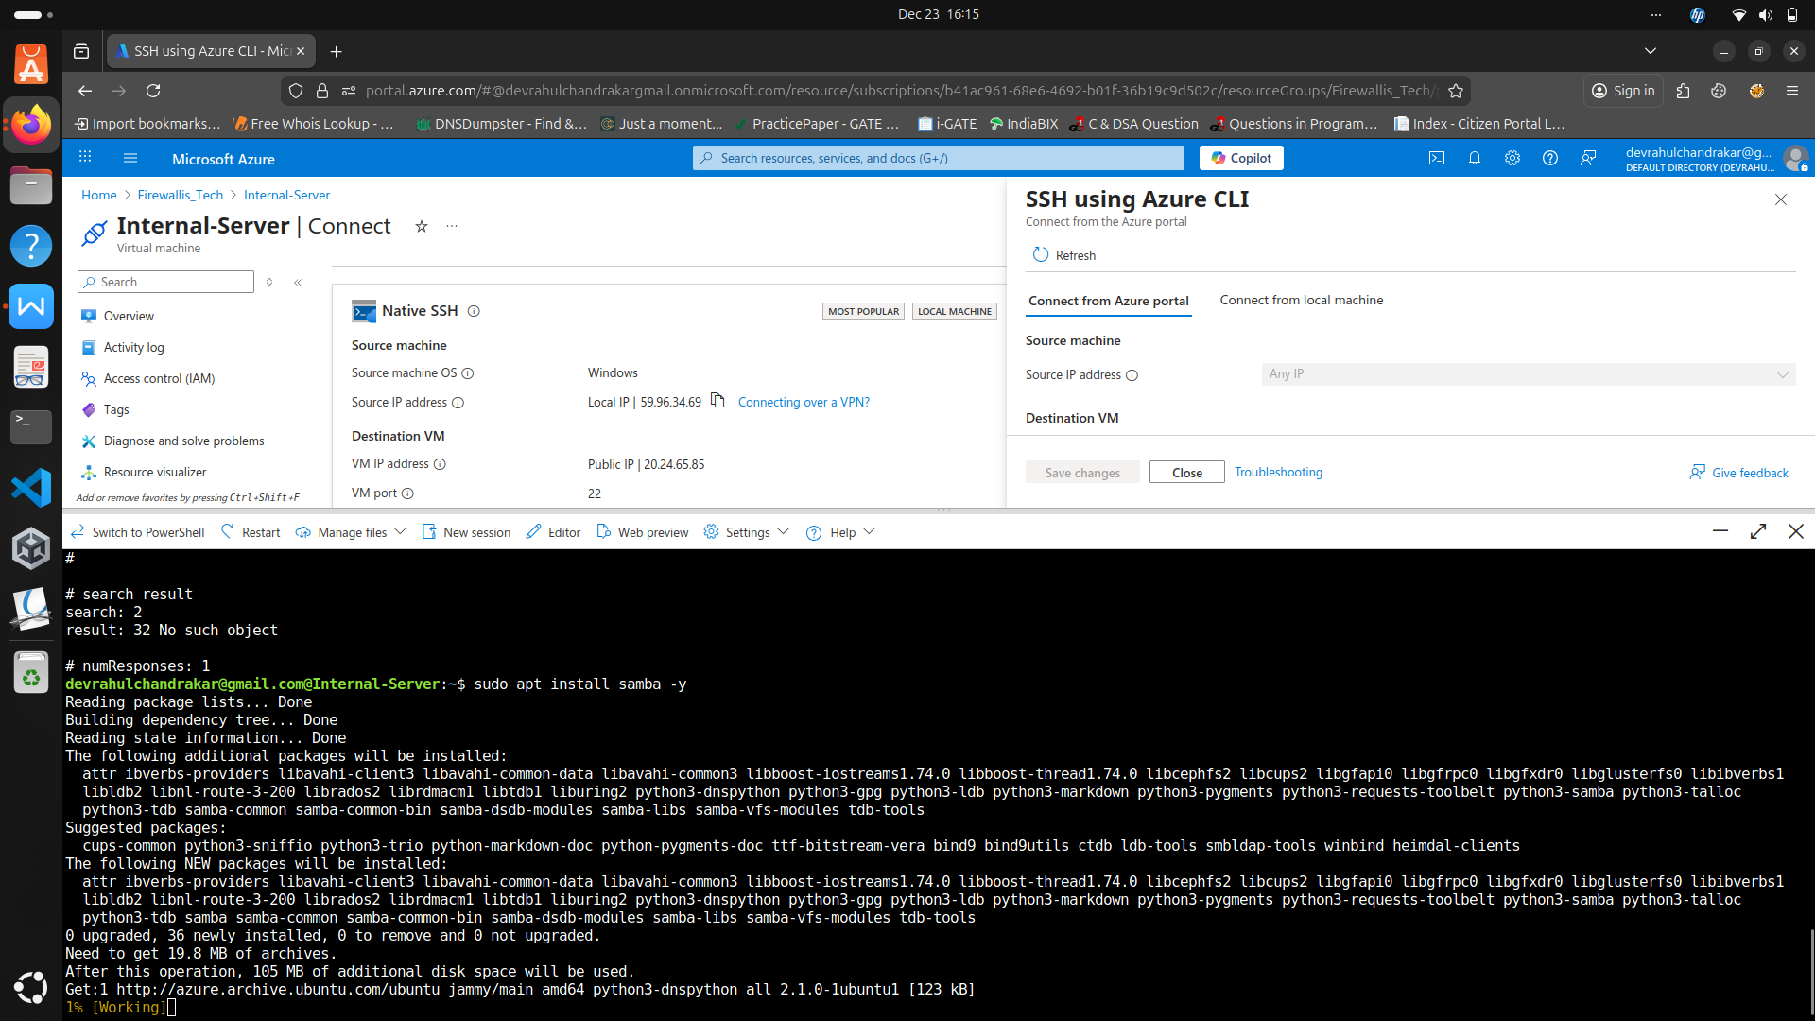

* Purpose: Simulate corporate identity management and file sharing
* Logging: Auth logs and system logs enabled for SIEM collection

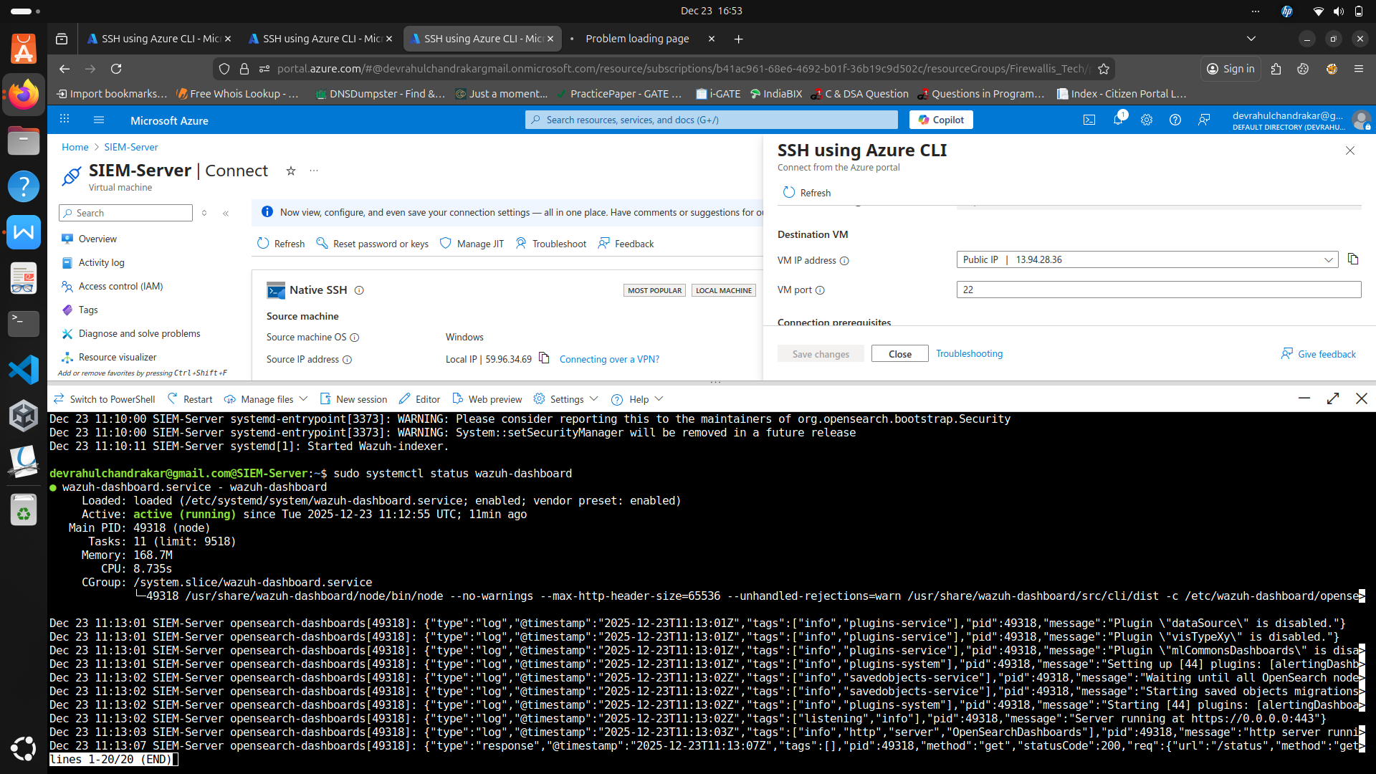

4.2.2 VM2: Apache Web Server (DMZ)

* Role: Web Server

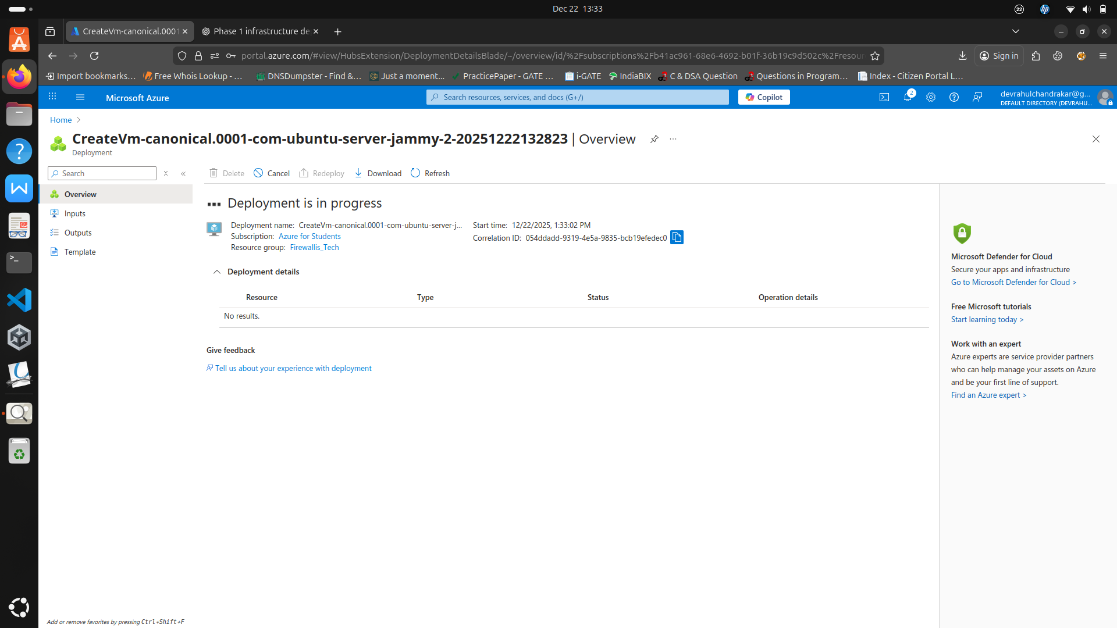

* Services Installed: Apache Web Server hosting a simple web application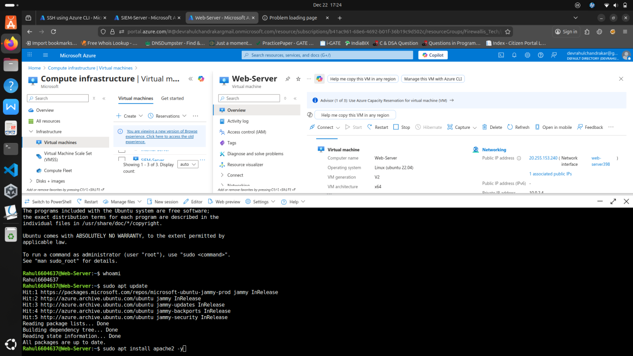
* Purpose: Simulate external-facing services prone to web attacks
* Logging: Web server access and error logs enabled for SIEM collection

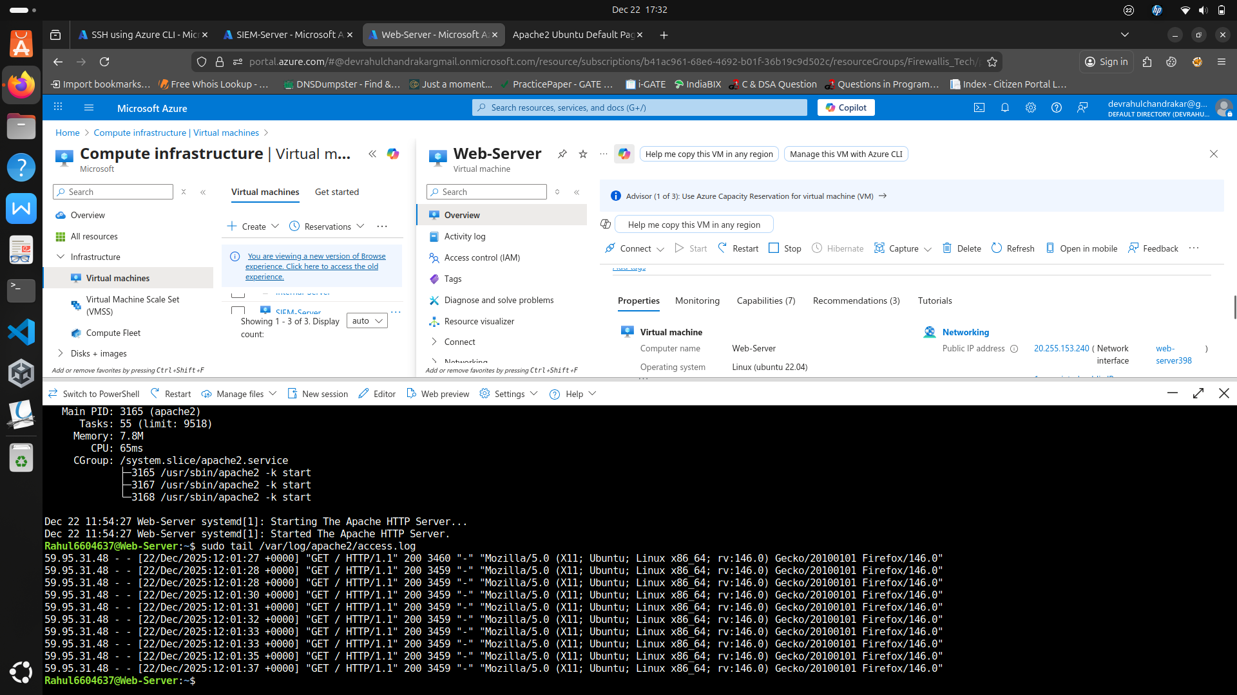

4.2.3 VM3: SIEM Server Setup

* Role: Log collection and monitoring
* Services Installed: Wazuh Server (Open-source SIEM)

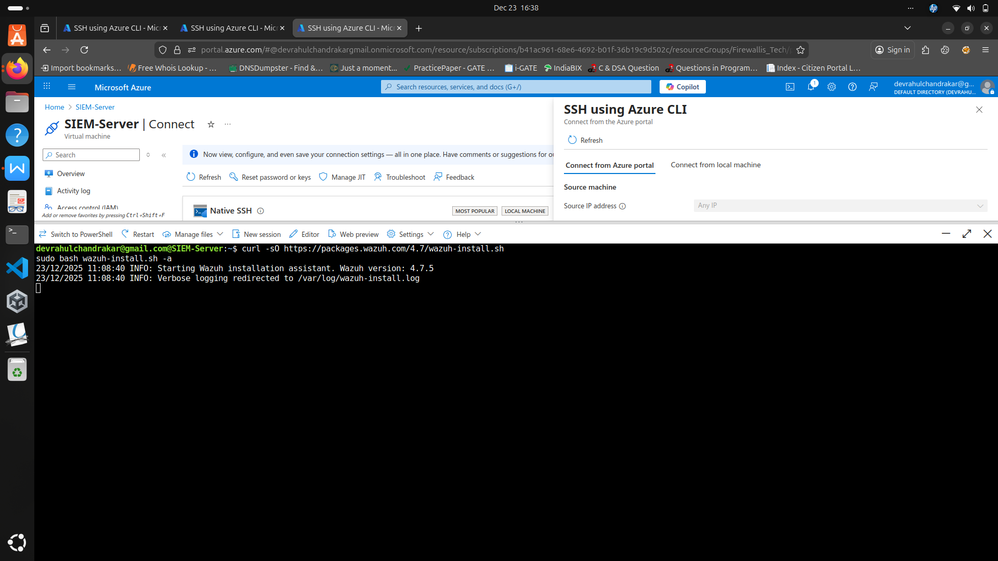

* Purpose: Centralized collection and analysis of logs from VM1 and VM2



* Logging: Configured Wazuh agents on VM1 and VM2 to forward logs to SIEM

4.3 SIEM Deployment

4.3.1 Wazuh Installation

* Wazuh server installed on VM3 using default configurations
* SIEM configured to monitor incoming logs from both internal and DMZ servers



4.3.2 Agent Configuration

* Wazuh agents installed on VM1 and VM2
* Agents configured to forward **auth.log, syslog, audit.log, and web server logs** to VM3

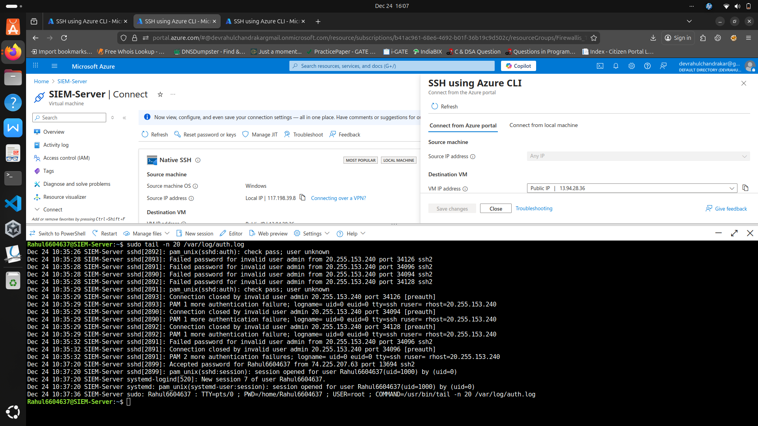

4.3.3 Log Forwarding

* Ensured real-time log forwarding to SIEM
* Enabled alerts for suspicious activity (brute-force attempts, unauthorized access, web attacks)

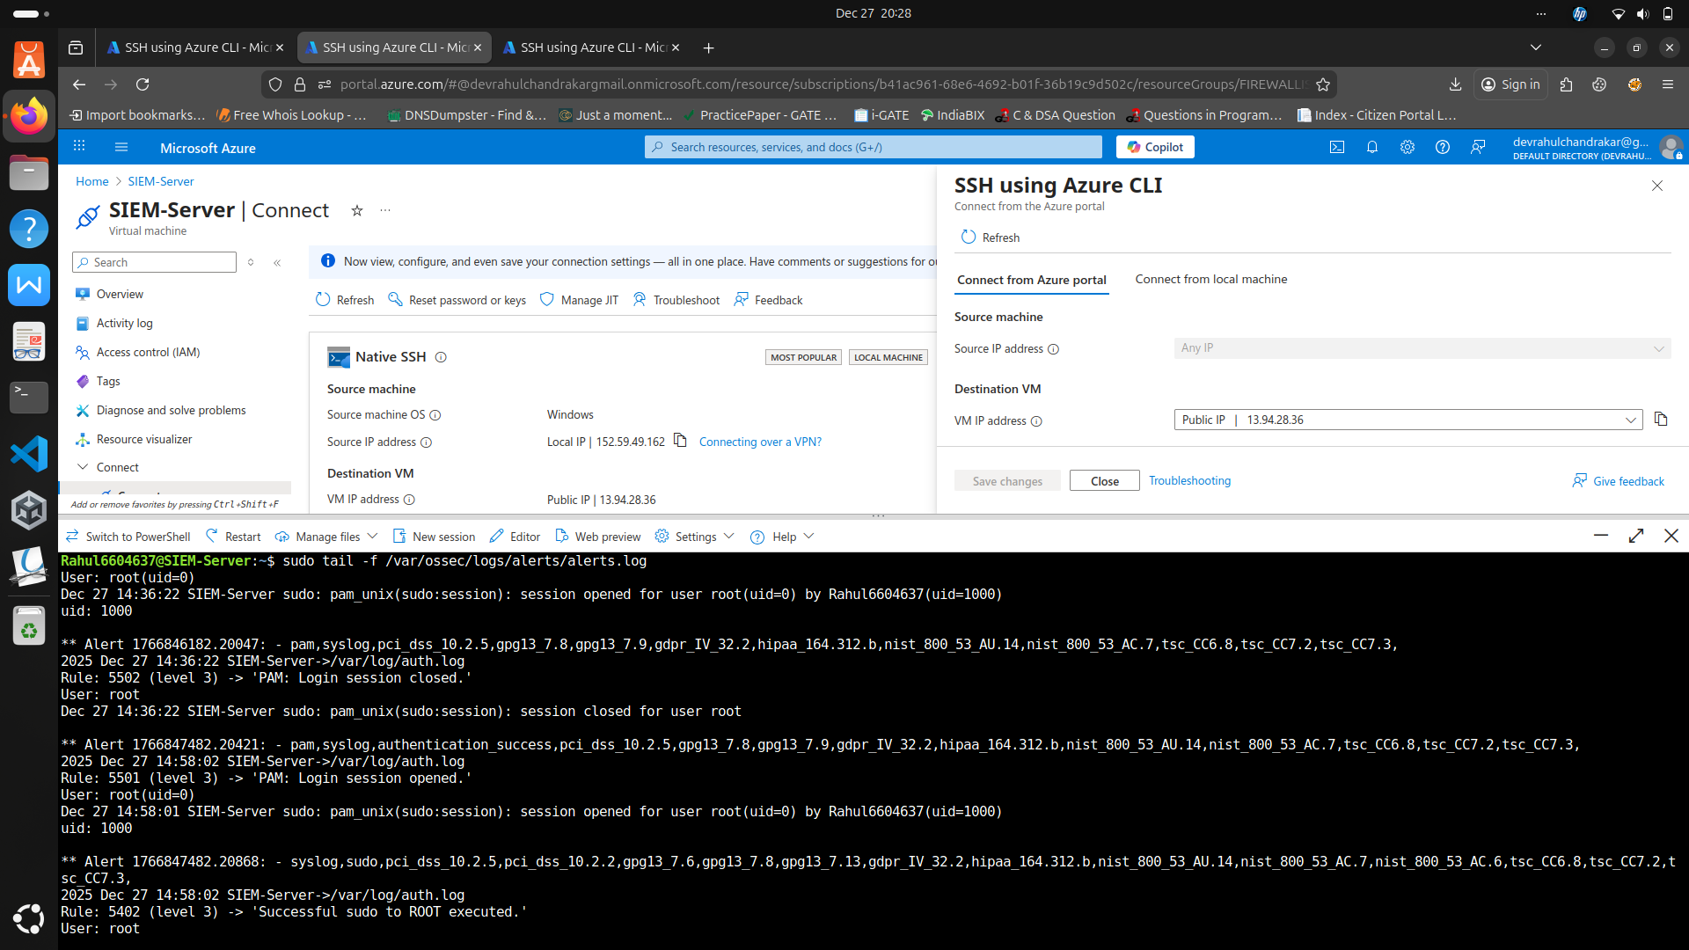

4.4 Attack & Hardening

4.4.1 Red Team Attacks

* **Network Scanning:** Nmap used to identify open ports and services

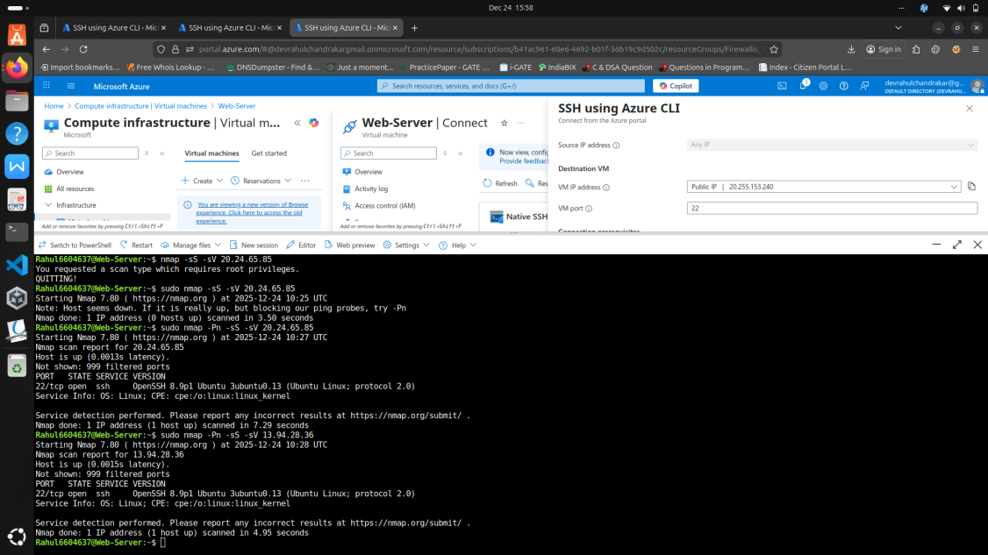

* **SSH Brute-force:** Hydra used to test weak authentication

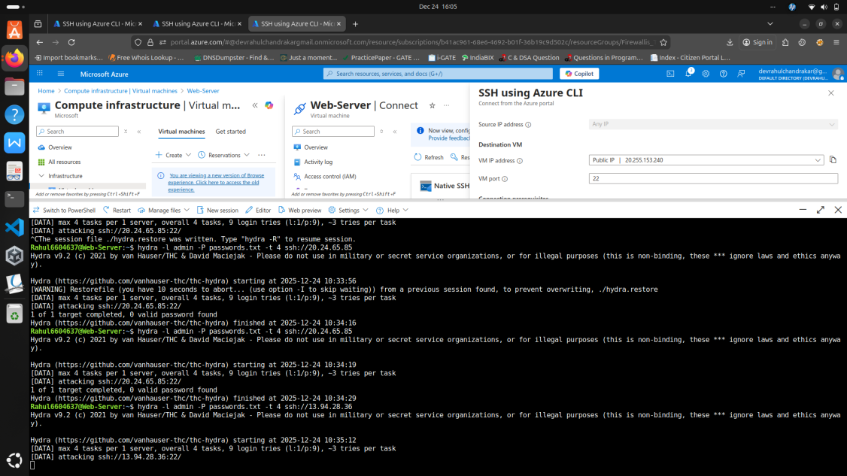

* **Web Enumeration:**Dirb and manual probing for directories and configuration files

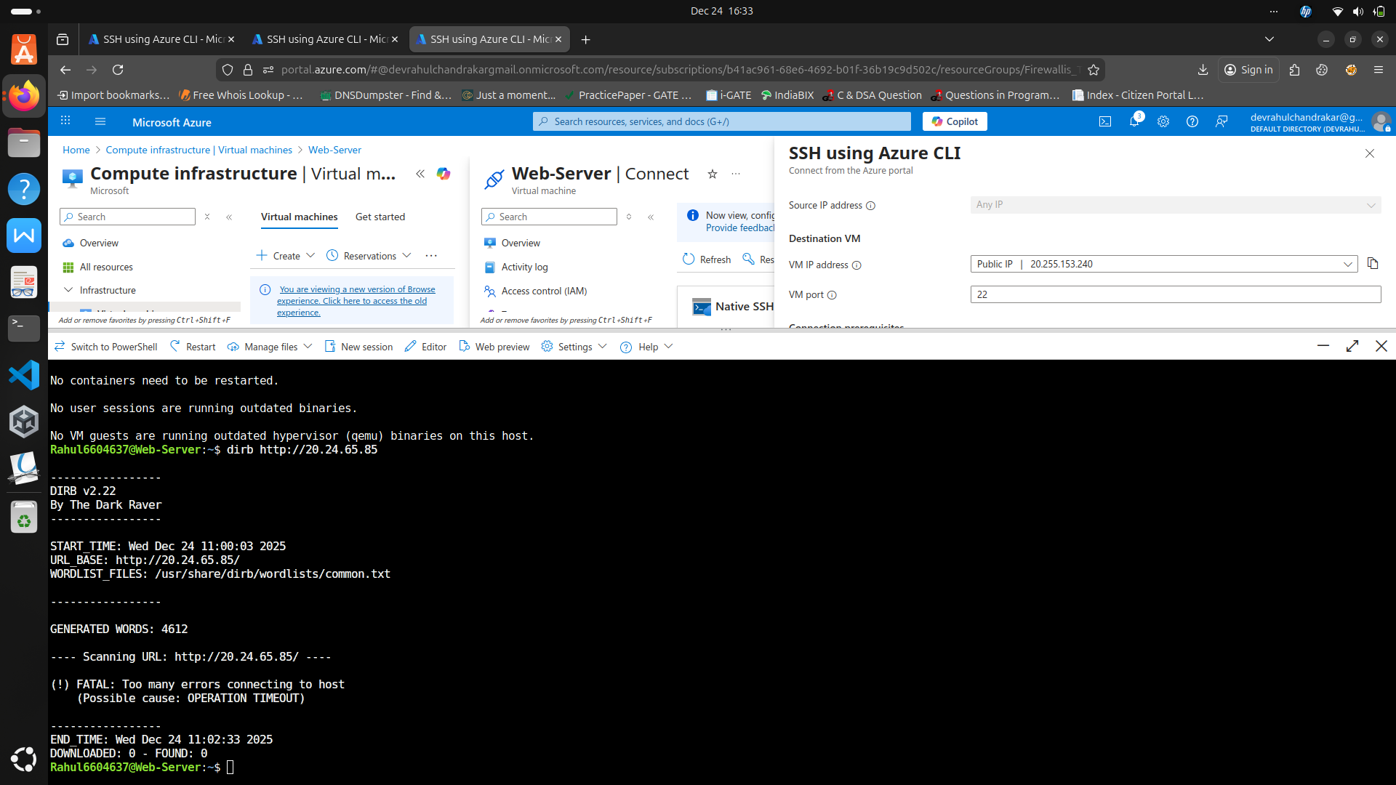

4.4.2 Log Analysis

* Wazuh dashboard monitored for generated alerts
* Auth logs, system logs, and web logs reviewed for indicators of compromise

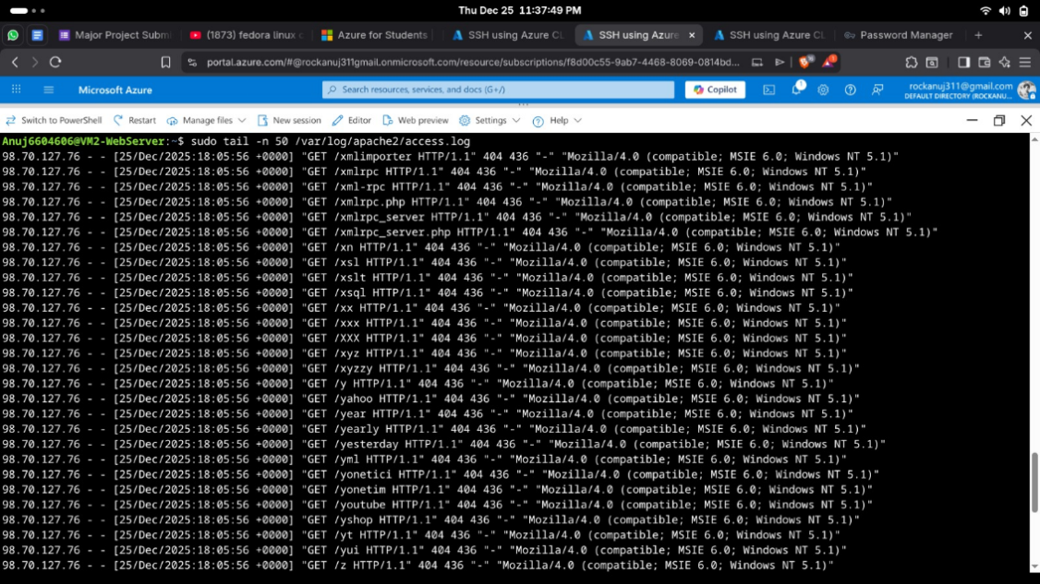

4.4.3 SSH Hardening

* Disabled root login (PermitRootLogin no)

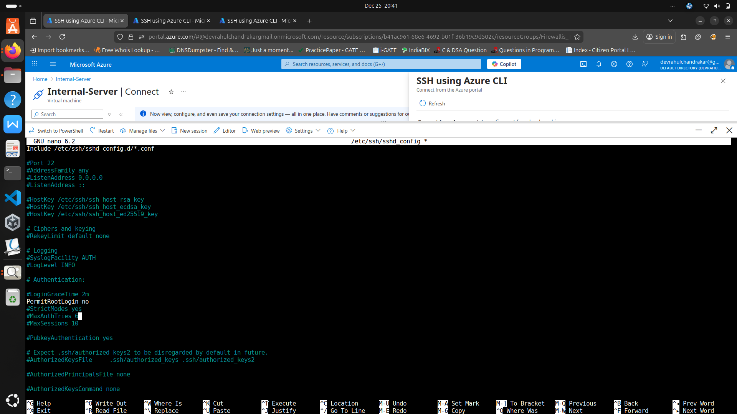

* Disabled password-based login (PasswordAuthentication no)

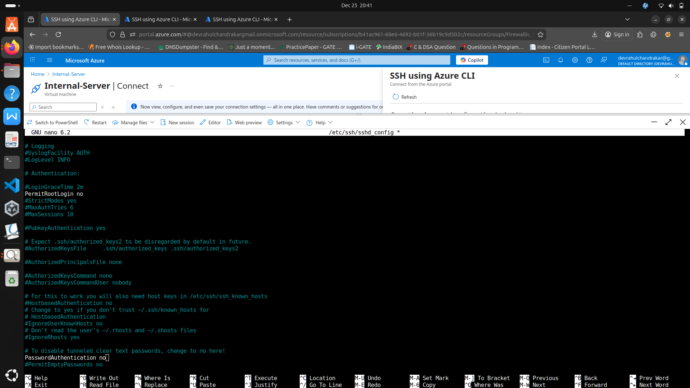

* Limited authentication attempts (MaxAuthTries 3)

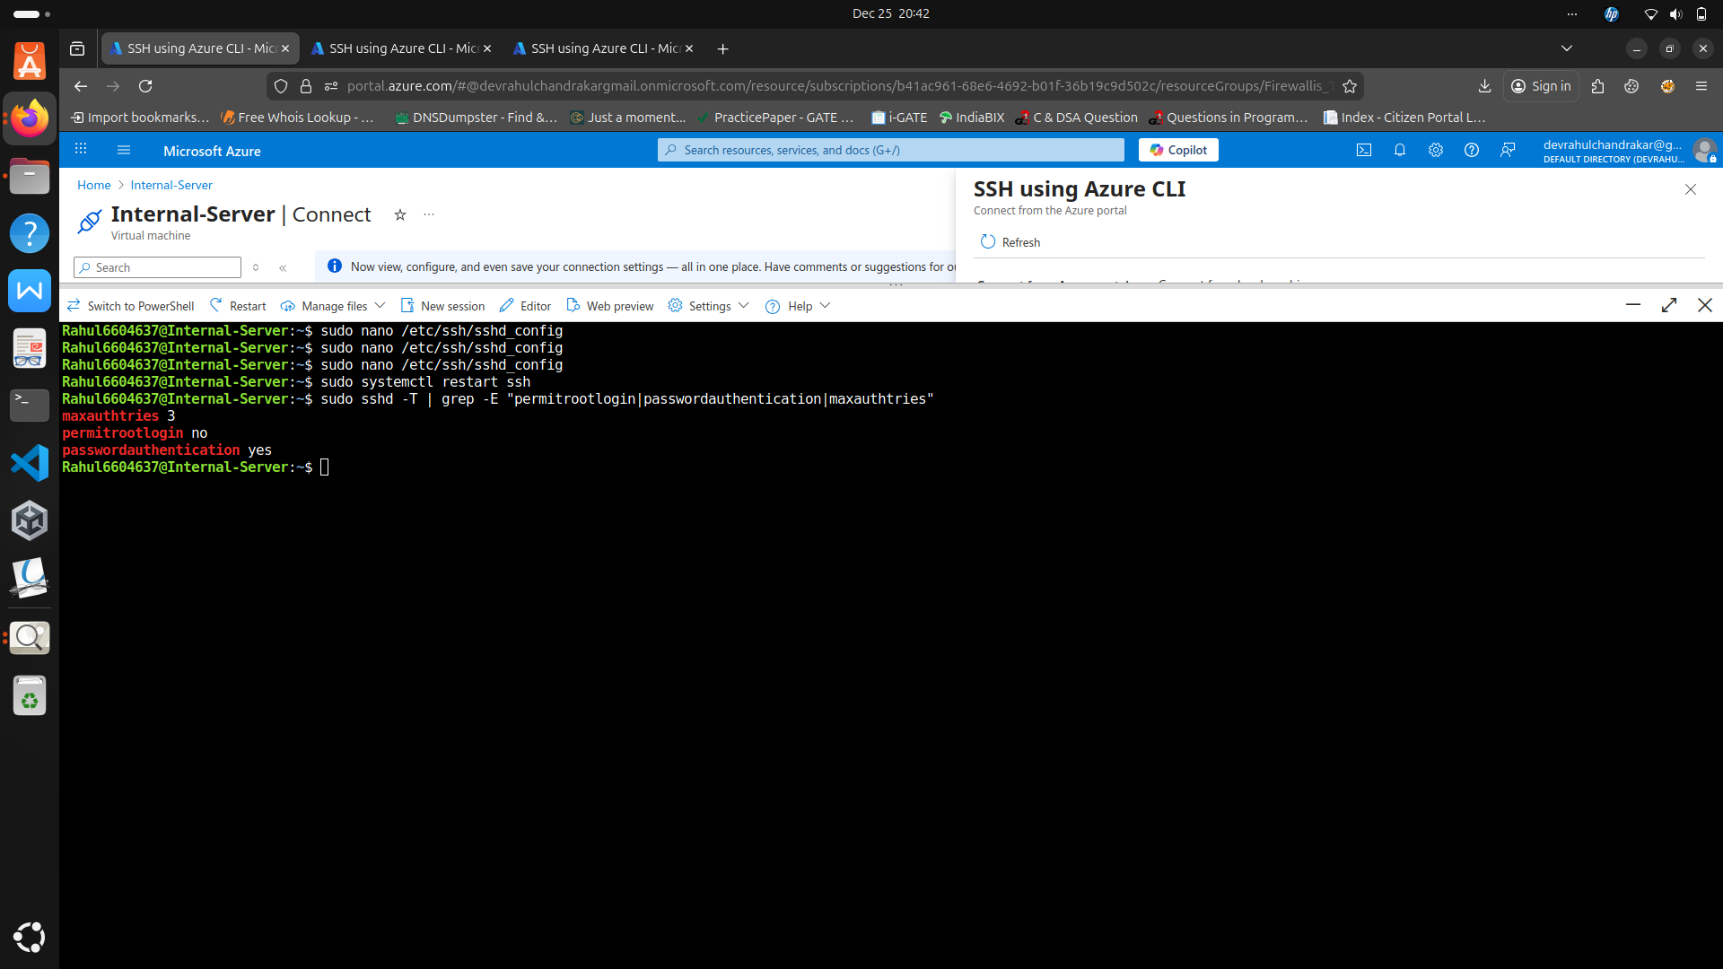

4.4.4 Firewall Configuration

* UFW installed on all VMs

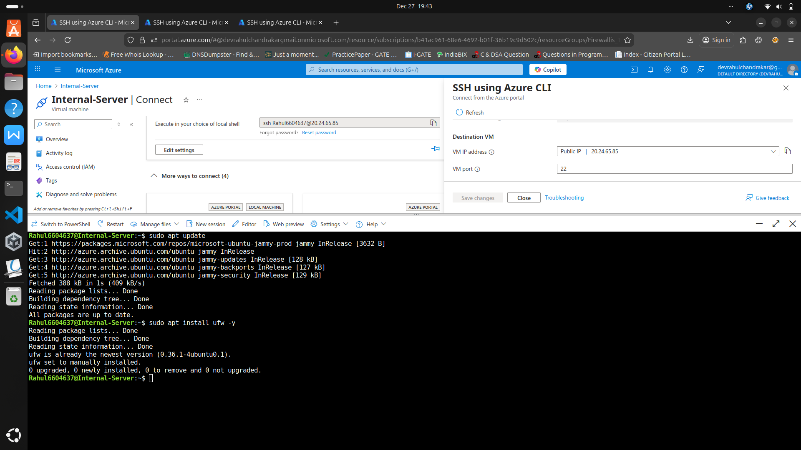

* Restricted incoming traffic to essential ports only (SSH, HTTP, Wazuh)

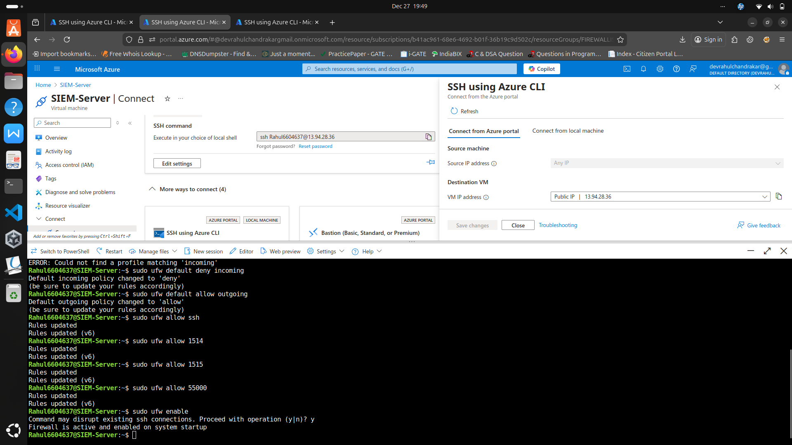

* Verified rules using ufw status verbose

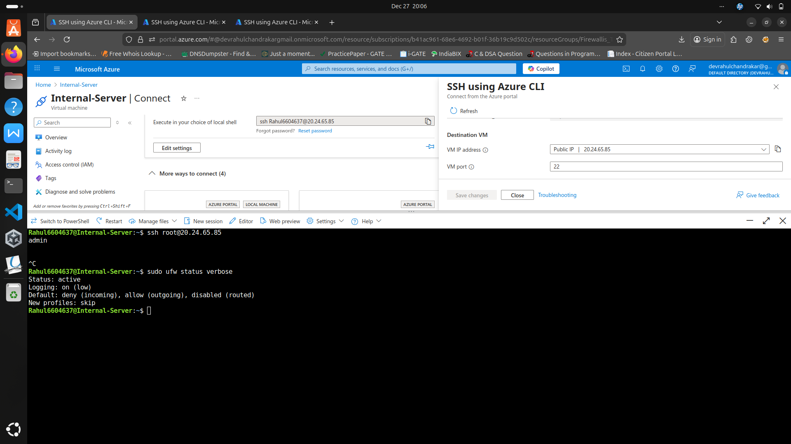

4.4.5 Re-Attack Validation

* Attacks repeated after hardening
* SIEM logs reviewed to confirm **reduced attack surface**
* Comparison of logs before and after hardening documented

4.5 Summary

The methodology demonstrates a **complete security lifecycle**: from deployment of a vulnerable cloud environment, through attack simulation, log analysis, and defensive hardening, to validation of security improvements. This approach provides practical, hands-on exposure to real-world cloud security and SOC operations.

**CHAPTER 5: RESULTS**

This chapter presents the results obtained after deploying, attacking, monitoring, and hardening the cloud-based infrastructure. The outcomes are analyzed by comparing the system behavior **before and after security hardening**, with a focus on attack success rate, log visibility, and SIEM effectiveness.

5.1 Infrastructure Deployment Results

A three-tier cloud infrastructure was successfully deployed on Microsoft Azure consisting of three Linux-based virtual machines. The environment included an Internal Server, a Web Server placed in a DMZ subnet, and a SIEM Server for centralized monitoring. All systems were interconnected using a single Virtual Network with appropriate subnet segregation.

The infrastructure operated as expected and generated system, authentication, and application logs required for security analysis.

5.2 Attack Simulation Results (Before Hardening)

Prior to implementing security controls, multiple attack simulations were performed from the attacker machine.

**Observed Results:**

* Nmap scans revealed multiple open ports and services.
* SSH brute-force attempts were allowed and generated repeated authentication failures.
* Web enumeration attempts accessed default paths and configuration probes.
* Apache access logs recorded suspicious requests such as directory traversal and configuration file probing.

These activities generated significant logs but were not actively blocked, demonstrating an insecure security posture.

5.3 SIEM Detection Results

The Wazuh SIEM successfully collected and analyzed logs from all monitored systems.

**Detected Events:**

* SSH authentication failures
* Port scanning activity
* Suspicious HTTP requests
* System and audit log events

Security alerts were generated in real time and visualized through the Wazuh dashboard, validating effective log ingestion and centralized monitoring.

5.4 Security Hardening Results

After identifying misconfigurations, multiple security controls were implemented, including:

* SSH hardening (root login disabled, password authentication disabled, reduced authentication attempts)
* Firewall enforcement using UFW and Azure NSGs
* Network access restrictions
* Apache web server security configuration
* Enhanced logging mechanisms

5.5 Re-Attack Results (After Hardening)

The same attacks were re-executed after applying security hardening.

**Observed Improvements:**

* Nmap scans showed most ports as filtered or inaccessible.
* SSH brute-force attacks failed due to restricted access and hardened authentication.
* Web enumeration attempts were limited and blocked.
* Firewall logs confirmed blocked connection attempts.

The attack surface was significantly reduced, and malicious activity was detected and prevented.

5.6 Comparative Analysis

|  |  |  |
| --- | --- | --- |
| **Security Aspect** | **Before Hardening** | **After Hardening** |
| Open Ports | Multiple | Minimal |
| SSH Protection | Weak | Strong |
| Firewall | Disabled | Enabled |
| Attack Success | High | Low |
| SIEM Alerts | Basic | Enhanced |

5.7 Overall Outcome

The results clearly demonstrate that implementing security best practices significantly improves system resilience. The hardened infrastructure effectively prevented attacks while providing enhanced visibility through SIEM monitoring.

**CHAPTER 6: CONCLUSION**

This project successfully simulated a real-world cloud security lifecycle involving deployment, attack, detection, and defense. A cloud-based enterprise infrastructure was deployed on Microsoft Azure and subjected to various cyber-attacks to generate realistic security events.

Security misconfigurations were identified through SIEM analysis and were systematically mitigated using industry-standard hardening techniques. Post-hardening results demonstrated a significant improvement in system security, reduced attack surface, and enhanced detection capabilities.

6.1 Security Improvements Achieved

* Hardened SSH configuration
* Firewall and network access control enforcement
* Secure web server configuration
* Centralized logging and monitoring using SIEM
* Effective detection and prevention of attacks

6.2 Learning Outcomes

Through this project, the following learning outcomes were achieved:

* Hands-on experience with cloud infrastructure deployment
* Practical understanding of cyber-attack techniques
* SOC-level log analysis using SIEM
* Linux system and network hardening skills
* Incident detection and response experience

6.3 Future Scope

The project can be extended by

* Implementing automated incident response
* Integrating threat intelligence feeds
* Adding IDS/IPS solutions
* Applying Zero Trust architecture
* Expanding to multi-cloud environments

This project successfully simulated a real-world cloud security lifecycle involving deployment, attack, detection, and defense. A cloud-based enterprise infrastructure was deployed on Microsoft Azure and subjected to various cyber-attacks to generate realistic security events.

Security misconfigurations were identified through SIEM analysis and were systematically mitigated using industry-standard hardening techniques. Post-hardening results demonstrated a significant improvement in system security, reduced attack surface, and enhanced detection capabilities.

6.1 Security Improvements Achieved

* Hardened SSH configuration
* Firewall and network access control enforcement
* Secure web server configuration
* Centralized logging and monitoring using SIEM
* Effective detection and prevention of attacks

6.2 Learning Outcomes

Through this project, the following learning outcomes were achieved:

* Hands-on experience with cloud infrastructure deployment
* Practical understanding of cyber-attack techniques
* SOC-level log analysis using SIEM
* Linux system and network hardening skills
* Incident detection and response experience

6.3 Future Scope

The project can be extended by

* Implementing automated incident response
* Integrating threat intelligence feeds
* Adding IDS/IPS solutions
* Applying Zero Trust architecture

Expanding to multi-cloud environments

**CHAPTER 7: REFERENCES**

1. Microsoft Azure Documentation – Virtual Networks, Virtual Machines, and Network Security Groups, Microsoft Corporation, 2024.
2. Wazuh Documentation – Security Information and Event Management (SIEM) Platform, Wazuh Inc., 2024.
3. Ubuntu Server Guide – Security and System Administration, Canonical Ltd., 2024.
4. Apache Software Foundation – Apache HTTP Server Documentation, Version 2.4, 2024.
5. FreeIPA Project – Identity Management for Linux, Red Hat, 2024.
6. Nmap Network Scanning – Gordon Lyon, Nmap Network Scanning, Insecure.Org, 2023.
7. OWASP Foundation – OWASP Top 10 Web Application Security Risks, 2024.
8. National Institute of Standards and Technology (NIST) – Guide to Computer Security Log Management (SP 800-92), 2023.

**CHAPTER 7: BIBLIOGRAPHY**

1. Lyon, G., Nmap Network Scanning, Insecure Communications, First Edition, 2023.
2. Stallings, W., Network Security Essentials: Applications and Standards, Pearson Education, Sixth Edition, 2022.
3. Shostack, A., Threat Modeling: Designing for Security, Wiley Publications, 2021.
4. Behl, A., Cybersecurity and Cyberwar: What Everyone Needs to Know, Oxford University Press, 2020.
5. Microsoft Corporation, Azure Security Best Practices, Microsoft Press, 2024.

**CHAPTER 7: APPENDIX**

Appendix A – Programs Used

* Nmap scanning commands
* Hydra SSH brute-force testing commands
* DIRB web directory enumeration
* SSH hardening configurations (sshd_config)
* UFW firewall rules
* Azure NSG configurations
* Wazuh agent and manager configuration files

Appendix B – Tools and Datasheets

* Microsoft Azure VM and Networking Datasheets
* Wazuh SIEM Architecture Documentation
* Apache HTTP Server Configuration Manual
* Ubuntu Server Security Guidelines
* FreeIPA Identity Management Documentation